Microsoft Azure Virtual Desktop



Azure Virtual Desktop for Business Premium Hands-on Lab

Version:

**V3**

Created by:

**Bogdan Grozoiu**

**&**   
**Joke Feije-Edelman**

# Table of Contents

1 Table of Contents 2

2 About the document 5

3 Version history 5

4 MFA Enforcement 5

5 System requirements 6

6 Account requirements 6

7 Configure your lab environment 6

7.1 Remote Desktop client 6

7.2 Create a new Azure tenant 7

7.3 Add the Lab environment subscription to your tenant 8

7.4 Create a new user to become Global Admin 8

7.5 Add the Admin account to the Edge Browser 8

7.6 Grant access on the subscription to the Global Admin 9

7.7 Add Microsoft Business Premium Licenses 10

7.8 Naming conventions Azure resources 11

8 Enable Multi Factor Authentication (MFA) 13

8.1 Prepare for Conditional Access 13

8.2 Conditional access - enforce MFA for administrators 13

8.3 Conditional access - enforce MFA for all users 15

9 Prerequisites – Virtual network 15

9.1 Create an Azure Virtual Network 15

10 Prerequisites – Log Analytics workspace 17

10.1 Create a Log Analytics workspace 17

11 Users and groups 18

11.1 Create users 18

11.2 Create groups 18

12 Azure Virtual Desktop 20

12.1 Create a Host pool 20

12.2 Configure the Application group for the workspace 22

12.3 Create an Application group for Azure Virtual Desktop Applications 23

12.4 Check the Workspace settings 25

13 Additional configuration for Azure Active Directory Azure Virtual Desktop 25

13.1 Host pool configuration 26

13.2 Permissions on the Virtual Machines & AADJoined check 26

13.3 Search for “SG-AVD” this will retrieve both AVD related groups created in section 11.1, Create users 27

13.4 Assign licenses 28

13.5 Conditional Access policy exception 29

14 Azure Virtual Desktop workspace 30

14.1 Connect to the Azure Virtual Desktop environment with the Remote Desktop application 31

14.2 Connect to the Azure Virtual Desktop environment with the browser 31

15 Best Practice 1: Scale the host pool for demand 33

16 Best Practice 2: Hybrid Scenarios 33

17 Appendix 1 – Language settings 33

17.1 Language settings in the Azure portal 33

18 Appendix 2 – Resources 33

18.1 Add Microsoft Business Premium Licenses – credit card required 33

18.2 Go to the Azure Portal (https://portal.azure.com ) using the Edge browser profile attached to your administrator account as created in paragraph 7.1 Remote Desktop client 34

18.3 Create a new Azure tenant 34

18.4 Add the Lab environment subscription to your tenant 35

18.5 Create a new user to become Global Admin 35

18.6 Add the Admin account to the Edge Browser 36

18.7 Grant access on the subscription to the Global Admin 37

18.8 Add Microsoft Business Premium Licenses 38

18.9 Sign-up for an Azure trial (credit card needed) 40

Disclaimer

© 2023 Microsoft Corporation. All rights reserved. This document is provided "as-is." Information and views expressed in this document, including URL and other Internet Web site references, may change without notice.

Microsoft may have patents, patent applications, trademarks, copyrights, or other intellectual property rights covering subject matter in this document. Except as expressly provided in any written license agreement from Microsoft, our provision of this document does not give you any license to these patents, trademarks, copyrights, or other intellectual property.

Microsoft customers and partners may copy, use, and share these materials for planning, deployment, and operation of Microsoft products.

# About the document

Azure Virtual Desktop is a desktop and app virtualization service that runs on the cloud.

Here's what you can do when you run Azure Virtual Desktop on Microsoft Azure:

* Set up a multi-session Windows 11 or Windows 10 deployment that delivers a full Windows experience with scalability
* Present Microsoft 365 Apps for enterprise and optimize it to run in multi-user virtual scenarios
* Bring your existing Remote Desktop Services (RDS) and Windows Server desktops and apps to any computer
* Virtualize both desktops and apps
* Manage desktops and apps from different Windows and Windows Server operating systems with a unified management experience

If your current customer is hosting its remote desktop services on-premises. This Microsoft Learn page might be of value to you.

[Move on-premises Remote Desktop Services to Azure Virtual Desktop - Cloud Adoption Framework | Microsoft Learn](https://learn.microsoft.com/en-us/azure/cloud-adoption-framework/migrate/azure-best-practices/contoso-migration-rds-to-wvd)

# Version history

V1 (May 2023):

* Initial version

V2 (June 2023)

* Updated based on the feedback initial runs

V3 (June 2023)

* Update on the Flow to configure your lab environment

# MFA Enforcement

Once you will receive your username and password, you will be forced to use your authenticator for the MFA with number matching. At the end of the event you can remove the entry from your authenticator

System requirements

As most configuration will be browser based, **a standard PC with recent Internet browser** with the “Remote Desktop” application (.msi version) installed on it or the ability to install the “Remote Desktop” application via .msi ([Windows 64-bit](https://go.microsoft.com/fwlink/?linkid=2139369)) will be sufficient for this lab.

The system used for this lab should contain a recent internet browser and the “Remote Desktop” application (msi deployment) or the ability to install the “Remote Desktop” application.

In this hands-on lab instructions we assume the usage of a PC with the Microsoft Edge browser.

To prevent constantly changing screens, it might be an idea to bring a small tablet or similar to keep this lab document open during the hands-on lab.

**Note**: The embedded Remote Desktop Connection application (or the one that can be downloaded from the app store) cannot be used with Azure Virtual Desktop due to .rdpw file requirements.

# Account requirements

During this hands-on lab, we will make use of a dedicated hands-on lab environment. There are no account pre-requisites.

# Configure your lab environment

## Remote Desktop client

To be able to connect to the Azure Virtual Desktop as a user, the Remote Desktop client needs to be installed on your computer.

Check if the application has been installed on your computer:

1. In the search bar in your Windows task bar, type “Remote Desktop”
2. If installed the application will be available in the search results
3. Open the application
4. Click the ellipses (…) in the right upper hand corner and select **About**
5. Check the version number of your application, this should be 1.2.4240.0 or higher. There should as well be a green checkmark with the text “You’re up to date ”.
6. If you are up to date, no further action is necessary, if not please follow the next steps to install the correct Remote Desktop application

Install the Remote Desktop application:

1. Use the following link to download the [Windows 64-bit](https://go.microsoft.com/fwlink/?linkid=2139369) version of the application.
2. Click on the downloaded file to install the application
3. After the install, follow the steps in the previous paragraph, to ensure the application installed successfully.

## Create a new Azure tenant

To be able to perform this lab an Azure tenant is needed. As you do not want to play around in your companies or customers Azure tenant, we will use a new tenant.

In this section you will find the steps to request such a tenant.

Note: Please use a new Microsoft account for this tenant to make sure the tenant is not linked to any existing environments.

Open the Edge browser using an InPrivate window.

1. **Open** the following page to request a new trial <https://signup.live.com>.
2. A sign in window appears. In this window click the “No account? **Create one**” link available
3. Click the **Get a new email address link**.
4. Create a new account name e.g. [avdrocks@outlook.com](mailto:avdrocks@outlook.com). Store the account name for later reference. Click the **Next** button.
5. Enter a new password for this account. Store the password for later reference. Click the **Next** button.
6. The message that a little more information is needed appears. Fill in a first and last name. Click the **Next** button.
7. Select your country and Birthdate. Click the **Next** button.
8. The message to solve a puzzle to prove you are not a robot appears. Click the **Next** button.
9. Solve the puzzle(s) and click **Submit**.
10. The **Confirmation Verification** complete appears on the screen and you are redirected to a new window page.
11. On this new page **fill in your information**. Make sure that as an email address you fill in the email address created in step 5.
12. Use one of the **verification methods** (Text or Call) to verify your phone number.
13. Select at least the “I agree to the customer agreement” box before clicking the **Next** button.
14. Your account has been created.
15. In the same browser window, open the azure portal <https://portal.azure.com>.
16. Login with your new user account (if needed).
17. A new tenant called mynewuseraccount.onmicrosoft.com e.g. avdrocksoutlook.onmicrosoft.com will be created. This can take a while to be fully available.

## Add the Lab environment subscription to your tenant

The email you received from your partner for this training contains a link to redeem your lab environment subscription.

1. Open the link from the email in an InPrivate Edge browser window.
2. Click on the **blue Labs button** to launch the lab.
3. Follow the steps in **Module 0** to redeem a subscription and add it to your previously created Azure Active Directory. Use the **account** that you have **just created**.
4. Instead of moving ahead with “Required Lab Setup” step, close the lab.

## Create a new user to become Global Admin

Your just created live account cannot perform all actions, so we need an account which is part of the Azure Active Directory tenant. In this section you will create a new user and assign the Global Administrator role to the user.

Login to the Azure Portal with the newly created outlook.com account in Edge using an InPrivate window.

1. In the **search bar** at the top of the Azure Portal, type “aad”.
2. In the **search results**, click “**Azure Active Directory**” under “Services”, the Azure Active Directory page will open
3. On the Azure Active Directory page, in the left hand navigation , under manage, click “**Users**”.
4. Click **New user**.
   1. Username: e.g. adminadv
   2. Name: e.g. Admin AVD
   3. Configure password: or use the generated one
   4. Assign the Global Administrator role
5. Click **Create**.

## Add the Admin account to the Edge Browser

To work in Microsoft Edge with another account it is recommended to work with an Microsoft Edge-profile linked to the account in this hands-on lab.

Usage of profile will allow for quick switching between this demo-environment and your production environment

1. Open a new instance of Microsoft Edge.
2. Click on the circle with your profile picture or initials in the top bar. (Depending on your browser version, it can be found in the top left or top right corner)
3. Click the settings icon in the top right corner
4. Click **Add a Browser**.
5. Click **Add** .
6. Click **Choose an account** and select **+ Add new account**
7. Click **Sign in to sync data**
8. Fill in the sign in information. (*Hint: username is* [*avdadmin@xxxx.onmicrosoft.com*](mailto:avdadmin@xxxx.onmicrosoft.com)) click **Next**.
9. Fill in the password and click **Sign in** .
10. The “More information is required” message will appear to setup MFA for this user. Click **Next**.
11. On the next page follow the steps to get the Authenticator app if not already installed on your device. Click **Next** when the Authenticator is installed.
12. In the Authenticator app click **Add an account** and select **Work or School**. In the browser wizard click **Next**.
13. In the Authenticator app click **Scan the QR code** and scan the QR code in the wizard in the browser and click Next
14. A number will appear in the wizard that should be filled in in the Authenticator and click **Yes**
15. After that approve with your personal Authenticator pin code, a “Notification approved” message will appear in the wizard in the browser.
16. Click **Next** in the browser wizard
17. A success message will appear, click **Done**.
18. If the question arises or you would like to stay signed in, click “**No**”.
19. Click **Next**.
20. Click **Finish**.

## Grant access on the subscription to the Global Admin

From a security perspective a new Global Administrator does not have access to any subscriptions or Management groups. Now you sign in as the newly created Global Administrator and grant yourself permissions to the Azure Pass Subscription.

Go to the Azure Portal (<https://portal.azure.com> ) using the Edge browser profile attached to your administrator account as created in paragraph “7.5 Add the Admin account to the Edge Browser”.

1. In the **search bar** at the top of the Azure Portal, type “aad”.
2. In the **search results**, click “**Azure Active Directory**” under “Services”, the Azure Active Directory page will open
3. On the Azure Active Directory page, in the left hand navigation , under manage, click “**Properties**”.
4. Adjust the toggle for “Access management for Azure resources” to **Yes**.

Note: This toggle is very powerful and will grant you all permissions on the tenant. In real-life do use only with a 4-eyes principle.

1. Click **Save** at the top of the page to confirm the adjusted setting.
2. As you browser cookies still might reference to your old permissions. Close the browser session. Start a new Edge browser using the Edge browser profile and logon with the same account to the azure portal.
3. In the **search bar** at the top of the Azure Portal, type “subscriptions”.
4. In the **search results**, click “**Subscriptions**” under “Services”, the Subscriptions page will open.
5. The **Azure Pass subscription** should be visible now.
6. Click on the Azure Pass subscription, the Azure Pass Subscription page will open.
7. On the Azure Pass Subscription page, in the left hand navigation , click “**Access Control (IAM)**”, the IAM page will open.
8. On the IAM page, click the **Add role assignment** button, to grant yourself owner permissions to this subscription.
9. In the Role Assignment wizard, on the Role tab, click **Privileged administrator roles**.
10. Select the **Owner** role and click **Next**.
11. On the Members tab, click the **+ Select members** link.
12. On the right hand side, search for your current account and click the **Select button**.
13. Click the **Review + Assign** **button**.
14. Click again the **Review + Assign** **button** .to grant the permissions.
15. As there is no need to have access to all resources anymore. You will turn off this feature. In the **search bar** at the top of the Azure Portal, type “aad”.
16. In the **search results**, click “**Azure Active Directory**” under “Services”, the Azure Active Directory page will open
17. On the Azure Active Directory page, in the left hand navigation , under manage, click “**Properties**”.
18. Adjust the toggle for “Access management for Azure resources” back to **No**.
19. Click **Save** at the top of the page to confirm the adjusted setting.
20. As you browser cookies still might reference to your old permissions. Close the browser session.

## Add Microsoft Business Premium Licenses

Time to add the Microsoft 365 Business Premium-licenses to the tenant. These licenses are trial licenses and can be used for a one-month period.

Go to the Azure Admin Portal (<https://admin.microsoft.com>) using the Edge browser profile attached to your administrator account as created in paragraph “7.5 Add the Admin account to the Edge Browser”.

1. Click **Billing** in the Microsoft 365 admin center.
2. Under Billing click **Purchase Services**.
3. Search for **Microsoft 365 Business Premium**.

**Note**: There are different offerings Microsoft 365. Please select the **Microsoft 365 Business Premium**. Make sure not to select the (month to month) offering.

1. Click **Details**
2. On the Microsoft 365 Business Premium page click **Start free trial version**.
3. Prove you are not a robot by providing your cell phone number. Click **Sms me**.
4. Provide your verification code and click **Start your free trial period**.
5. Click **Try now**.
6. Click **Continue**.

You return to the homepage of the Microsoft 365 admin center.

1. Expand **Billing** and click **Licenses**.

Check or the Microsoft 365 Business Premium licenses are available to you

Note: In case the following message will appear, click **Continue**and take a close look the steps in this section.

## Naming conventions Azure resources

Just as with an on-premises environment, it makes sense to use a naming convention for the resources created within Azure. Give this naming convention some thought before creating any resources within the Azure tenant. Not all resources can be renamed after the creation and you will end up with inconsistent named resources.

An example of a naming convention:

<max 4 letter abbreviation of the azure resource>-<environment>-<Azure region the resource resides>-<optional: purpose>-<serial number>

For a resource group in the Production environment, hosted in Western Europe, supporting the platform networking resources, the following name would suit the naming convention: “rg-p-we-network-01”.

For a Log Analytics Workspace in the acceptance environment, hosted in Northern Europe, the following name would suit the naming convention: “law-a-ne-01”.

# Enable Multi Factor Authentication (MFA)

The primary security measure for every organization **MUST** be to enable multi-factor authentication for **ALL USERS**.

Although a “Man in the Middle” phishing attack can go around MFA, by injecting the MFA token (see <https://aka.ms/EvilGinx>) is provides more security than Single Factor Authentication.

This hands-on-lab will start with a check if the **Security Standards** have been enabled in this tenant. These “Security Standards” are by default enabled for all Azure-tenants provisioned after November 2020.

The Security Standards” are a limited set of minimal security settings to enable MFA for the Tenant.

## Prepare for Conditional Access

In this step a custom policy will be created to configure a conditional access policy which enables a more fine-grained MFA implementation.

Go to the Azure Portal (<https://portal.azure.com> ) using the Edge browser profile attached to your administrator account as created in paragraph “7.5 Add the Admin account to the Edge Browser”.

1. In the **search bar** at the top of the Azure Portal, type “aad”.
2. In the **search results**, click “**Azure Active Directory**” under “Services”, the Azure Active Directory page will open.
3. On the Azure Active Directory page, in the left select the tab **Properties**.
4. At the very bottom of the page, under the “Access management for Azure Resources”section, click on the **Manage security defaults** link.
5. By default, the Security defaults are enabled.
6. Turn the Security defaults off, by selecting **Disabled (not recommended)**.
7. Select **My organization uses Conditional Access**.
8. To confirm your selection, click **Save** at the bottom of the page
9. Confirm the pop-up prompt.
10. Click the X icon in the upper right corner.

## Conditional access - enforce MFA for administrators

The first policy which we will configure is to enforce MFA for all accounts with privileged access, like global administrators or Helpdesk administrators.

The policy will be enabled in the Report only mode, this is the safest way to start with conditional access (You want to avoid the possibility that you lock yourself out of the tenant).

Go to the Azure Portal (<https://portal.azure.com> ) using the Edge browser profile attached to your administrator account as created in paragraph “7.5 Add the Admin account to the Edge Browser”.

1. In the **search bar** at the top of the Azure Portal, type “aad”.
2. In the **search results**, click “**Azure Active Directory**” under “Services”, the Azure Active Directory page will open.
3. On the Azure Active Directory page, in the left-hand navigation, under manage, click **Security**.
4. On the Security | Getting started page, in the left-hand navigation, under Protect, click **Conditional Access**.
5. Click **Create new policy**.
6. Name: **MFA for admins**.
7. Assignments>Users, click **0 users and groups selected**.
8. On the **Include** tab, select **Select users and groups** and check the box in front of **Directory roles**.
9. Select all roles on which you like to enable MFA. As a bare minimum select at least the Global Administrator role.
10. Under “Cloud apps or actions” click **No cloud apps, actions, or authentication contexts selected**.
11. On the **Include** tab, select **All cloud apps**.
12. Access control>Grant, click **0 controls selected**.
13. Under the section “Access controls” click on the option **Grant access**.
14. Check the box in front of **Require multifactor authentication**.
15. Confirm at the bottom, click **Select**.
16. Under the section “Session” click **0 controls selected**.
17. Select **Persistent browser session > Never persistent**.

Note: for safety reasons, you don’t want to allow permanent browser sessions as these browser sessions can remain active even when the browser is restarted.

1. Confirm at the bottom, click **Select**.
2. Confirm that the Enable policy is set to **Report only**.
3. Click **Create**.

Note: the conditional access policy can exclude users from signing in. By default the user configuring the policy will be excluded from the policy to prevent a lockout of the tenant.

1. Click **I understand that my account will be impacted by this policy. Proceed anyway**.
2. Confirm at the bottom, click **Create**.

As an example this policy will be configured as Report only. The next policy for the users will be configured as enforce..

## Conditional access - enforce MFA for all users

This second policy will enforce conditional access for all users who sign in on the M365 applications, like Exchange Online and Microsoft Teams as well as the Azure portal.

1. We assume you are still in the Azure Active Directory portal on the Conditional Access policy page. If this is not the case please follow step 1-5 from the previous section 8.2“Conditional access - enforce MFA for
2. Click **Create new policy**.
3. Name: **MFA for users**.
4. Assignments>Users, click **0 users and groups selected**.
5. On the **Include** tab, select **Select users and groups** and check the box in front of **All Users**.
6. Assignments>Cloud apps or actions, click **No cloud apps, actions, or authentication contexts selected**.
7. On the **Include** tab, select **Select apps**.
8. Click **None** under Select
9. Select **Office 365**
10. Confirm at the bottom, click **Select**.
11. Access control>Grant, click **0 controls selected**.
12. Select **Grant access**.
13. Check the box in front of **Require multifactor authentication**.
14. Confirm at the bottom, click **Select**.
15. Toggle the Enable policy switch to **On**.
16. Click **Create**.
17. Click **I understand that my account will be impacted by this policy. Proceed anyway**.
18. Confirm at the bottom, click **Create**.

# Prerequisites – Virtual network

To be able to set up a Azure Virtual Desktop environment, an Azure Virtual Network (vnet) is required. For every network it is important to use a range of unique IP addresses. Connected networks cannot use the same IP address ranges. As this hands-on lab is a green field situation, no interference is expected but in a customer environment you most likely enter a brownfield situation.

## Create an Azure Virtual Network

Go to the Azure Portal (<https://portal.azure.com> ) using the Edge browser profile attached to your administrator account as created in paragraph “7.5 Add the Admin account to the Edge Browser”.

1. In the **search bar** at the top of the Azure Portal, type “vnet”.
2. In the **search results**, click “**Virtual Networks**” under “Services”, the virtual networks page will open
3. On the Virtual Networks page, click “**Create**” in the menu bar to start the creation of a new Virtual Network.
4. In the “Create Virtual Network wizard” select the **subscription** in which this Virtual Network will reside.
5. For the Resource group, select “**Create new**” and fill in the name of the Resource Group, e.g. “rg-p-we-network-01”
6. On the Instance details, fill in the **Name** of the Virtual Network, e.g. “vnet-p-we-01”.
7. Select the **Region** in which the Virtual Network will be created, “West Europe”.
8. Click **Next : IP Addresses**, to continue to the next tab in the wizard.
9. In the **IPv4 address space**, fill in the IP range for this Virtual Network, e.g. 10.0.0.0/24. By default the wizard will propose an IP range. You are able to adjust the range or remove it for the IP ranges for this network by using the recycle bin icon behind the range. Make sure you have an appropriate amount of IP addresses available within the network. How many is dependent on which workloads will land in this virtual network. Proper network planning is just as important for Azure as it is for an on-premises environment.
10. Every Virtual Network, needs one or more subnets. The wizard already proposes a default subnet for this network. You are able to adjust the configuration of this subnet by clicking it. You can add more than one subnet at this moment or add more in a later stage. For now we will adjust the default subnet, containing all ip-addresses in the Virtual Network, without a NAT gateway or Service Endpoints selected and give it a name following our naming conventions, e.g. “snet-p-we-01”.  
    *NOTE: If the wizard does not propose a default subnet then click on “****Add subnet”*** *and give the subnet the same range as the IPv4 address space as you added in the previous step.*
11. Click **Next : Security** to continue to the next tab in the wizard
12. For now a **BastionHost** is not necessary, select “Disable”.
13. **DDoS Network Protection** is a valuable service to protect resources exposed to the internet. However this also is a more expensive service, so be conscious if the risk is worth the costs. For this lab we will leave the option for DDoS Network Protection disabled.
14. In a real-life scenario it is recommended to consider the usage of an [Azure Firewall](https://learn.microsoft.com/en-us/azure/firewall/overview) in your Virtual Network. As the focus of the hands-on-lab is on the Azure Virtual Desktop we select “Disable”.
15. Click **Next : Tags** to continue to the next tab in the wizard
16. Optionally add one or more tags to this resource. Tags can be used for all kind of purposes but are mostly configured to associate resources to a cost center to enable the split of costs.
17. Click **Next : Review + Create** to continue to the next tab in the wizard
18. Review all selections and if all is well, click **Create** to deploy the Virtual Network and its subnet.
19. A notification will be displayed when the deployment of the resources has been completed.

# Prerequisites – Log Analytics workspace

To create an Azure Virtual Desktop environment we first need a Log Analytics workspace. A Log Analytics workspace is a unique environment that logs data from Azure Monitor and other Azure services, such as Azure Virtual Desktop, but it is also used by Microsoft Sentinel and Microsoft Defender for Cloud. Each workspace has its own data repository and configuration but might combine data from multiple services. It is recommended to centralize the usage of Log Analytics workspaces, as the power of the data resides in the ability to combine the data and find correlations. In many SMB Azure environments, only one Log Analytics workspace will be needed within the Azure environment.

## Create a Log Analytics workspace

Go to the Azure Portal (<https://portal.azure.com> ) using the Edge browser profile attached to your administrator account as created in paragraph “7.5 Add the Admin account to the Edge Browser”.

1. In the **search bar** at the top of the Azure Portal, type “log”.
2. In the **search results**, click “**Log Analytics workspaces**” under “Services”, the Log Analytics workspaces page will open
3. On the Log Analytics workspaces page, click “**Create**” in the menu bar to start the creation of a new Log Analytics workspace.
4. In the “Create Log Analytics workspace wizard” select the **subscription** in which this Log Analytics workspace will reside.
5. For the Resource group, select “**Create new**” and fill in the name of the Resource Group, e.g. “rg-p-we-management-01”
6. On the Instance details, fill in the **Name** of the Log Analytics workspace, e.g. “law-p-we-01”.
7. Select the **Region** in which the Virtual Network will be created, “West Europe”.
8. Click **Next : Tags** to continue to the next tab in the wizard
9. Optionally add one or more tags to this resource. Tags can be used for all kind of purposes but are mostly configured to associate resources to a cost center to enable the split of costs.
10. Click **Next : Review + Create** to continue to the next tab in the wizard
11. Review all selections and if all is well, click **Create** to deploy the Log Analytics workspace.
12. A notification will be displayed when the deployment of the resource has been completed.

Pre-requisites - Users and groups

When deploying an Azure Virtual Desktop environment this usually is to support a particular set of users within an organization. In a real-life scenario, you will need to investigate which users have what requirements and specifications and then design the solution for the different user types. In this hands-on-lab we assume we will have a user base for a workspace environment and a user base for the availability of specific applications via Azure Virtual Desktop.

In this hands-on-lab, we will create 2 groups of users to represent this user base and grant access to the solution.

Create users

In this section 3 users will be created which will be used in this hands-on-lab.

* AdeleV
* MeganB
* NestorW

Go to the Azure Portal (<https://portal.azure.com> ) using the Edge browser profile attached to your administrator account as created in paragraph “7.5 Add the Admin account to the Edge Browser”.

1. In the **search bar** at the top of the Azure Portal, type “aad”.
2. In the **search results**, click “**Azure Active Directory**” under “Services”, the Azure Active Directory page will open
3. On the Azure Active Directory page, in the left hand navigation , under manage, click “**Users**”.
4. Click **New user**.
   1. Username: AdeleV
   2. Name: Adele Vance
   3. Configure password: be creative and write the password down
   4. Uncheck the box that users should update the password on next logon
5. Click **Create**.
6. Repeat steps 4 and 5 for, **Nestor Wilkens** & **Megan Bowen**

Create groups

In this section 2 groups which will be created which each represent a user base.

* SG-AVD workspace users
* SG-AVD application users

Go to the Azure Portal (<https://portal.azure.com> ) using the Edge browser profile attached to your administrator account as created in paragraph “7.5 Add the Admin account to the Edge Browser”.

1. In the **search bar** at the top of the Azure Portal, type “aad”.
2. In the **search results**, click “**Azure Active Directory**” under “Services”, the Azure Active Directory page will open
3. On the Azure Active Directory page, in the left hand navigation , under manage, click “**Groups**”.
4. Click **New group**.
5. Group type: **Security**  
   Group name: **SG-AVD workspace users**  
   Group description: **Security group for all users which use the Azure Virtual Desktop workspace**  
   Azure AD roles can be assigned to the group: **No**

Membership type: **Assigned**

1. Owner: Select yourself as an owner.
2. Members: Select the users :  
   **AdeleV**  
   **MeganB**
3. Click **Create**.
4. Click **New group** .
5. Group type: **Security**  
   Group name: **SG-AVD application users**  
   Group description: **Security group for all users which use the Azure Virtual Desktop applications**  
   Azure AD roles can be assigned to the group: **No**

Membership type: **Assigned**

1. Owner: Select yourself as an owner.
2. Members: Select the users   
   **MeganB**  
   **NestorW**
3. Click **Create.**
4. Click **Refresh** to view the 2 newly created Security groups.

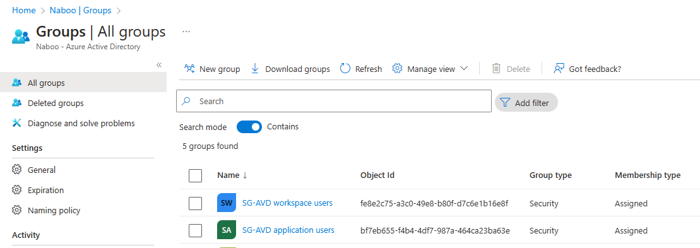

Azure Virtual Desktop

A host pool holds the compute power necessary for Azure Virtual Desktop. It is a collection of Azure virtual machines that register to Azure Virtual Desktop as session hosts when you run the Azure Virtual Desktop agent. All session host virtual machines in a host pool should be sourced from the same image for a consistent user experience. You control the resources published to users through application groups.

A host pool can be one of two types:

* Personal, where each session host (Virtual Machine) is assigned to an individual user. Personal host pools provide dedicated desktops to end-users that optimize environments for performance and data separation.
* Pooled, where user sessions can be load balanced to any session host (Virtual Machine) in the host pool. There can be multiple different users on a single session host at the same time. Pooled host pools provide a shared remote experience to end-users, which ensures lower costs and greater efficiency.

## Create a Host pool

Go to the Azure Portal (<https://portal.azure.com> ) using the Edge browser profile attached to your administrator account as created in paragraph “7.5 Add the Admin account to the Edge Browser”.

1. In the **search bar** at the top of the Azure Portal, type “avd”.
2. In the **search results**, click “**Azure Virtual Desktop**” under “Services”, the Azure Virtual Desktop page will open.
3. On the Azure Virtual Desktop page, click the “**Create a host pool**” button to start the creation of a new Host pool.
4. In the “Create a host pool wizard” select the **subscription** in which this Azure Virtual Desktop Host pool will reside.
5. For the Resource group, select “**Create new**” and fill in the name of the Resource Group, e.g. “rg-p-we-avd-01”.
6. On the Instance details, fill in the **Name** of the host pool, e.g. “hp-p-we-01”.
7. Select the **Region** in which the Virtual Network will be created, “West Europe”.
8. Validation environment: This setting is used for testing configuration changes ie. a production environment. As this is an initial deployment, Select **No**.
9. Preferred app group type: You can choose here whether you want a full Azure Virtual Desktop available to your users on only want to make applications available. In this lab we start with a Azure Virtual desktop, so select **Desktop**.
10. Host pool type, in most SMB cases you want users to share the host pool to be as efficient with the resources as possible. In some cases you need dedicated resources for users and in that case you can decide to use a personal host pool. For this hands-on-lab, select **Pooled**.
11. Load balancing algorithm, keep the selected **Breadth-first**.
12. Max session limit, set to **2** users per session host.
13. Click **Next : Virtual Machines** to continue to the next tab in the wizard.
14. On the Virtual Machines page in the wizard, there is the ability to configure the Virtual Machines used in the host pool. The advantage of adding the Virtual Machines here is that the Azure Virtual Desktop agent will already be installed on the Virtual Machines. For **Add Azure virtual machines**, select **Yes**.
15. Resource group for the virtual machines, keep the default value (displayed already in grey) in which the resource group of the host pool will be used.
16. Name prefix, type the prefix which will be used for these virtual machines, e.g. “avd”.
17. Virtual machine location, select **West Europe**.
18. Availability options, select for this hands-on-lab **No infrastructure redundancy required**. In a real-life scenario, this setting will depend on the level of availability necessary. A higher level of availability will impact the costs.
19. Security type, select for this hands-on-lab **Standard**. In a real-life scenario, this setting will depend on the level of security the service needs to enforce.
20. Image, select the most recent image for this hands-on-lab, **Windows 11**. **Enterprise multi-session + M365 Apps, version 22H2**.   
    Note: Because you have the Microsoft Business Premium licenses in your tenant, the Windows 11 Enterprise license is available to you.
21. Select the required Virtual Machine size: e.g. **D4as_v5**. Please note that by default quotas are applied on your Azure tenant, also with regards to the amount of CPUs per region per subscription. In many cases this quota can be adjusted when there is a need for more than the current quota allows. Some quotas can be adjusted by the global administrator of your tenant, but for others a support ticket is needed.
22. Number of VMs, type **2** for this hands-on-lab.
23. OS disk type, keep the preselected **Standard SSD**.
24. Boot diagnostics, for this hands-on-lab, select **Disable**.
25. Virtual Network, select here the Virtual Network created in paragraph 9.1 Create an Azure Virtual Network.
26. Subnet, select here the subnet created in paragraph 9.1 Create an Azure Virtual Network.
27. Network Security Group, for this hands-on-lab, select **None**. In a real-life scenario, plan for security using Network Security Groups, Firewalls etcetera.
28. Select which directory you would like to join, select **Azure Active Directory**.
29. Enroll VM in Intune, for this hands-on-lab, select **No**, in a real-life scenario enrolling the VMs in Intune is a cloud native way to manage these devices.
30. Fill in your own Virtual Machine Administrator account and password, e.g. account avdadmin and make a note of the username and password.
31. Custom Configuration script URL, is not applicable for this hands-on-lab.
32. Click **Next : Workspace** to continue to the next tab in the wizard.
33. On the workspace page, select **Yes** for Register desktop app group.
34. To this workspace, click **Create new** and type a name, e.g. wsp-p-we-01
35. Click **Next : Advanced** to continue to the next tab in the wizard.
36. Enable diagnostic settings, for this hands-on-lab, keep the box **unchecked**. In a real-life scenario these diagnostics logs can be stored in the Log Analytics workspace. However you need to be aware that data that you store will have a cost associated with that.
37. Click **Next : Tags** to continue to the next tab in the wizard.
38. Optionally add one or more tags to this resource. Tags can be used for all kind of purposes but are mostly configured to associate resources to a cost center to enable the split of costs.
39. Click **Next : Review + Create** to continue to the next tab in the wizard
40. Review all selections and if all is well, click **Create** to deploy the host pool, Virtual Machines and workspace.
41. A notification will be displayed when the deployment of the resources has been completed. **Please wait until the deployment succeeds before moving to the next step.**

## Configure the Application group for the workspace

An application group is a logical grouping of applications installed on session hosts in the host pool.

An application group can be one of two types:

* RemoteApp, where users access the RemoteApps you individually select and publish to the application group. Available with pooled host pools only.
* Desktop, where users access the full desktop. Available with pooled or personal host pools.

Users/groups will be assigned to an application group. As an application group is part of a workspace, in this way, by assigning users/groups to an application group users will be assigned to workspaces.

In the previous step where you created a host pool using the wizard, you as well already created a Desktop application group. In this section you will further configure this Desktop Application group.

Go to the Azure Portal (<https://portal.azure.com> ) using the Edge browser profile attached to your administrator account as created in paragraph “7.5 Add the Admin account to the Edge Browser”.

1. In the **search bar** at the top of the Azure Portal, type “avd”.
2. In the **search results**, click “**Azure Virtual Desktop**” under “Services”, the Azure Virtual Desktop page will open.
3. On the Azure Virtual Desktop page, in the left hand navigation click “**Application groups**” under Manage.
4. See that the creation of the host pool also created a matching application group named <host pool name>-DAG. Click on this resource.
5. In the middle of the page you see that one applications is part of the application group and this application group has no assignments for now.  
   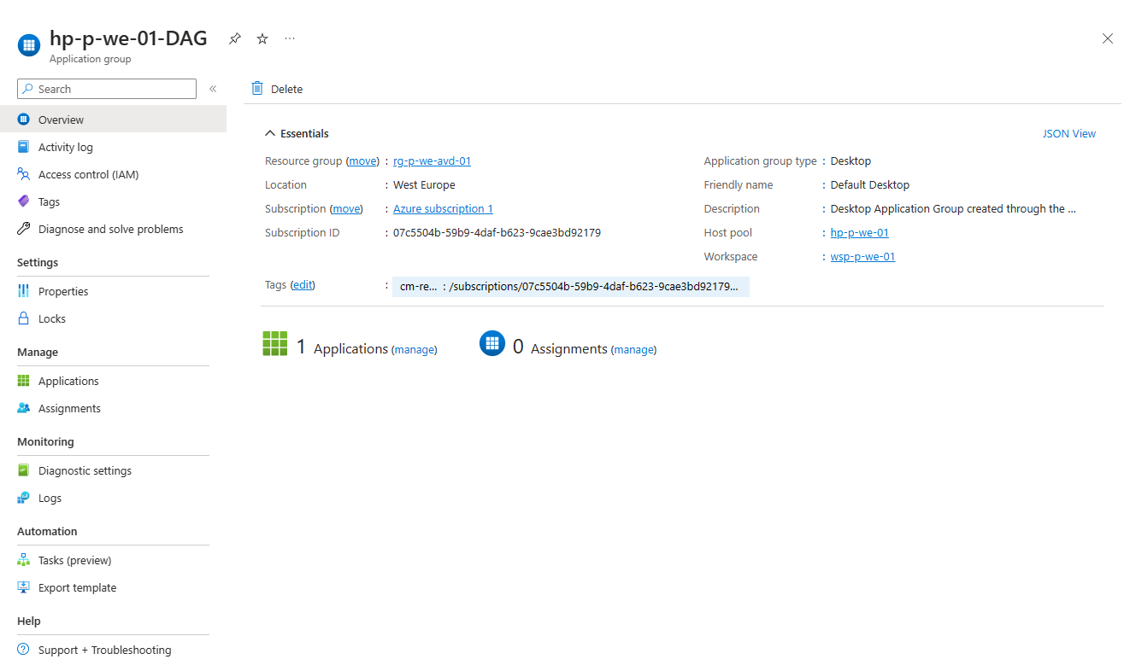
6. Click on the **(manage)** link under Applications in the middle of the page and see that the Desktop is available in this Application group.
7. Click the X icon in the upper right corner to close the page and go back to the Application group page.
8. Click on the **(manage)** link under Assignments in the middle of the page and see that no users or groups have been assigned to this Application group.
9. Click **Add**.
10. Search for the **SG-AVD workspace users** group, select the group and confirm the selection by clicking the **Select** button at the bottom of the page.
11. Click the X icon in the upper right corner to close the page and go back to the Assignments page.
12. Click the X icon in the upper right corner to close the page and go back to the Application group page.

## Create an Application group for Azure Virtual Desktop Applications

You can also publish an (line of business) application instead of a full desktop for specific users. To configure this we will create a new Application group (RemoteApp). After the creation of the new Application Group, it will be associated with the existing “wsp-p-we-01” resource.

Go to the Azure Portal (<https://portal.azure.com> ) using the Edge browser profile attached to your administrator account as created in paragraph “7.5 Add the Admin account to the Edge Browser”.

1. In the **search bar** at the top of the Azure Portal, type “avd”.
2. In the **search results**, click “**Azure Virtual Desktop**” under “Services”, the Azure Virtual Desktop page will open.
3. On the Azure Virtual Desktop page, in the left hand navigation click “**Application groups**” under Manage.
4. Click **Create**.
5. In the “Create an application group” wizard select the **subscription** in which this Azure Virtual Desktop Application Group will reside.
6. For the Resource group, select the Resources group newly created in 12.1, Create a Host pool“, e.g. “rg-p-we-avd-01”.
7. For the Host pool, select the Host pool newly created in 12.1, Create a Host pool“, e.g. hp-p-we-avd-01. After the selection the Location will be prefilled and cannot be adjusted.
8. For Application group type, select **Remote App (RAIL)**.
9. For Application group type, add the abbreviation AAG (For Applications Application Group) to the host pool name to be consistent with the naming of the Desktop Application Group, e.g. “hp-p-we-avd-01-AAG”.
10. Click **Next : Applications** to continue to the next tab in the wizard.
11. On the Applications in the wizard, there is the ability to add Applications, click **+Add applications** link to select applications.  
    *Note: Under* ***Application Source*** *you can select the option Start Menu, File path or MSIX Packadge for various scenarios. For this lab we focus on Start Menu applications.*
12. Select some of the M365 Apps (at least Word), by selecting the app and to confirm using the Save button at the bottom of the page. Repeat step 11-12 for all apps you want to include.
13. Click **Next : Assignments** to continue to the next tab in the wizard.
14. On the Assignments tab in the wizard, click the **+ Add Azure AD users or user groups** link.
15. Search for the **SG-AVD application users** group, select the group and confirm the selection by clicking the **Select** button at the bottom of the page.
16. Click the X icon in the upper right corner to close the page and go back to the Assignments page.
17. Click **Next : Workspace** to continue to the next tab in the wizard.
18. Set Register application group to **Yes**, the Workspace name will be prefilled as there can only be one Workspace been registered per Azure Virtual Desktop host pool.
19. Click **Next : Advanced** to continue to the next tab in the wizard.
20. On the Advanced tab in the wizard, you can enable diagnostic settings. For this hands-on-lab, keep the box **unchecked**. In a real-life scenario these diagnostics logs can be stored in the Log Analytics workspace. But be conscious of what to log as the amount of data has cost impact.
21. Click **Next : Tags** to continue to the next tab in the wizard.
22. Optionally add one or more tags to this resource. Tags can be used for all kind of purposes but are mostly configured to associate resources to a cost center to enable the split of costs.
23. Click **Next : Review + Create** to continue to the next tab in the wizard.
24. Review all selections and if all is well, click **Create** to deploy the Application group.
25. A notification will be displayed when the deployment of the resource has been completed.

## Check the Workspace settings

In the previous section in this chapter, we’ve created and added Application groups to the Azure Virtual Desktop Workspace. In this section, just for reference we’ll look into the settings of the Azure Virtual Desktop Workspace, named wsp-p-we-01 associated with the Azure Virtual Desktop host pool.

Go to the Azure Portal (<https://portal.azure.com> ) using the Edge browser profile attached to your administrator account as created in paragraph “7.5 Add the Admin account to the Edge Browser”.

1. In the **search bar** at the top of the Azure Portal, type “avd”.
2. In the **search results**, click “**Azure Virtual Desktop**” under “Services”, the Azure Virtual Desktop page will open.
3. On the Azure Virtual Desktop page, in the left hand navigation click “**Workspaces**” under Manage.
4. **Click** on the **wsp-p-we-01 resource**, the wsp-p-we-01 page opens.
5. On the Workspace page, in the left hand navigation click “**Application groups**” under Manage.
6. Note that the 2 Application groups (DAG and AAG) are associated with this workspace.

# Additional configuration for Azure Active Directory Azure Virtual Desktop

To support Azure Virtual Desktop with Azure Active Directory as authentication provider without any Directory Services some additional configuration is needed. This chapter describes these additional configuration items.

* Host pool configuration
* Permissions on the Virtual Machine
* Active Directory joined hosts
* User licensing
* Conditional Access policy exception

Host pool configuration

In the Host pool properties, the RDP properties need to be set to use Azure Active Directory to sign in for RDP.

Go to the Azure Portal (<https://portal.azure.com> ) using the Edge browser profile attached to your administrator account as created in paragraph “7.5 Add the Admin account to the Edge Browser”.

1. In the **search bar** at the top of the Azure Portal, type “avd”.
2. In the **search results**, click “**Azure Virtual Desktop**” under “Services”, the Azure Virtual Desktop page will open.
3. On the Azure Virtual Desktop page, in the left hand navigation click “**Host pools**” under Manage.
4. On the Azure Virtual Desktop page, click on the host pool created in 12.1
5. Click **RDP Properties** in the left hand navigation under Settings.
6. On the Connection information tab, set the Azure AD authentication from “Not configured” to “**Connections will use Azure AD authentication to provide Single sign-on**”.
7. Leave the next option “Credential Security Support Provider” to the default **“RDP will use CredSSP if the operating system supports CredSSP**”
8. Check the options available under the tabs “Session behaviour", “Device Redirection”, “Display Settings” and “Advanced”.
9. Leave all other options as is;
10. Click **Save** to confirm the new setting.

Permissions on the Virtual Machines & AADJoined check

As Azure Active Directory is used as authentication and authorization provider, the users who will use the Azure Virtual Desktop Virtual Machines need permissions to logon to these Virtual Machines. The minimal set of permissions needed for is the “Virtual Machine User Login” role.

The following instructions on assigning permissions to the Virtual Machines in the host pools needs to be performed for every Azure Virtual Desktop Virtual Machine.

Next to this the Virtual Machines need to be Azure Active Directory joined, as this configuration check has to be performed on every Virtual Machine, these steps will be combined to reduce clicking in the Azure Portal.

Go to the Azure Portal (<https://portal.azure.com> ) using the Edge browser profile attached to your administrator account as created in paragraph “7.5 Add the Admin account to the Edge Browser”.

1. In the **search bar** at the top of the Azure Portal, type “avd”.
2. In the **search results**, click “**Azure Virtual Desktop**” under “Services”, the Azure Virtual Desktop page will open.
3. On the Azure Virtual Desktop page, in the left hand navigation click “**Host pools**” under Manage.
4. On the Azure Virtual Desktop page, click on the host pool created in 12.1
5. Under Virtual Machines in the middle of the page, Click on **Total machines**, a screen with an overview of the Virtual Machines in the host pool is displayed.
6. Click on the first Virtual Machine, named <prefix>-0.
7. On the summary page, **click again on the name of the Virtual Machine**, which leads you to its homepage.
8. Click **Access Control (IAM)** in the left hand navigation.
9. Click on the “**Add**” button and choose “**Add role assignment**”
10. On the Add role assignment wizard, search for the **Virtual Machine User login** role, select this role and click **Next**.
11. On the Members tab, keep Assign Access to on **User, group, or service principal**
12. Click **+ Select members**.

Search for “SG-AVD” this will retrieve both AVD related groups created in section 11.1, Create users

In this section 3 users will be created which will be used in this hands-on-lab.

* AdeleV
* MeganB
* NestorW

Go to the Azure Portal (https://portal.azure.com ) using the Edge browser profile attached to your administrator account as created in paragraph “7.5 Add the Admin account to the Edge Browser”.

1. In the **search bar** at the top of the Azure Portal, type “aad”.
2. In the **search results**, click “**Azure Active Directory**” under “Services”, the Azure Active Directory page will open
3. On the Azure Active Directory page, in the left hand navigation , under manage, click “**Users**”.
4. Click **New user**.
   1. Username: AdeleV
   2. Name: Adele Vance
   3. Configure password: be creative and write the password down
   4. Uncheck the box that users should update the password on next logon
5. Click **Create**.
6. Repeat steps 4 and 5 for, **Nestor Wilkens** & **Megan Bowen**
7. Create groups. Select both **groups** and confirm by clicking the **Select**-button at the bottom of the page.
8. Click **Next**.
9. Click the **Review + assign** button.
10. A notification will be displayed when the assignments have been completed.
11. Click **Extensions + applications** in the left-hand navigation under Settings.
12. Check or the AADLoginforWindows extension is available.
13. Repeat steps 5 – 18 for every other Virtual Machine in the host pool.

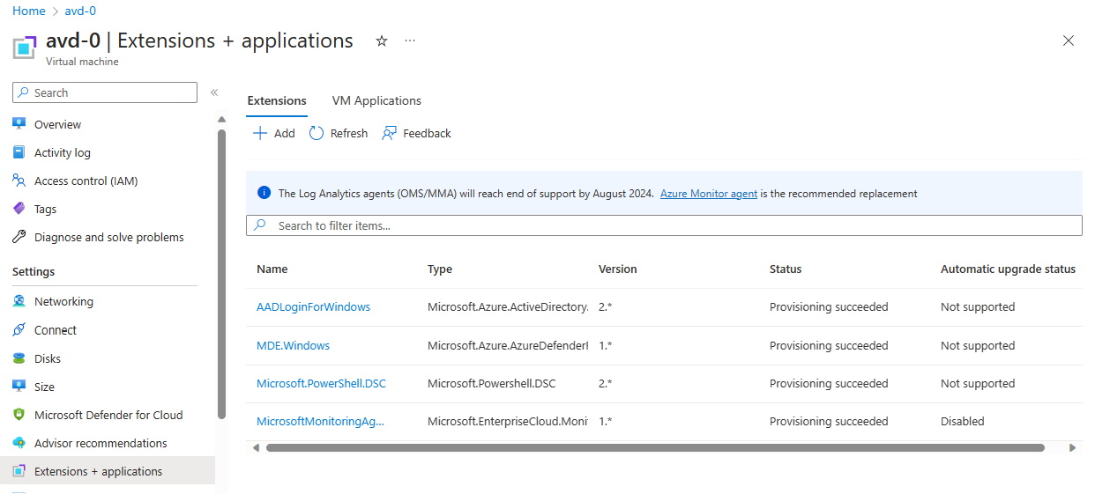

In case the installation of the Virtual Machine extension has failed, use the following link [Troubleshoot deployment problems](https://learn.microsoft.com/en-us/azure/active-directory/devices/howto-vm-sign-in-azure-ad-windows#troubleshoot-deployment-problems).

Assign licenses

Although it is possible to assign licenses to individuals, it is easier to assign the licenses to a group. In this hands-on-lab we will assign the license for the usage of Windows Enterprise to the groups “SG-AVD workspace users” and “SG-AVD application users”.

Go to the Azure Portal (<https://portal.azure.com> ) using the Edge browser profile attached to your administrator account as created in paragraph “7.5 Add the Admin account to the Edge Browser”.

1. In the **search bar** at the top of the Azure Portal, type “aad”.
2. In the **search results**, click “**Azure Active Directory**” under “Services”, the Azure Active Directory page will open.
3. On the Azure Active Directory page, in the left hand navigation , under manage, click “**Groups**”.
4. Click **SG-** **AVD workspace users**.
5. In the left hand navigation , under manage, click **Licenses**.
6. Click **Assignments** in the top menu bar.
7. Select **Windows 10/11 Enterprise**.
8. Click **Save**.
9. Click twice on the X icon in the upper right corner.
10. Repeat step 4-9 voor **SG-AVD application users**.

Conditional Access policy exception

Go to the Azure Portal (<https://portal.azure.com> ) using the Edge browser profile attached to your administrator account as created in paragraph “7.5 Add the Admin account to the Edge Browser”.

1. In the **search bar** at the top of the Azure Portal, type “aad”.
2. In the **search results**, click “**Azure Active Directory**” under “Services”, the Azure Active Directory page will open.
3. On the Azure Active Directory page, in the left hand navigation , under manage, click **Security**.
4. On the Security page, in the left hand navigation , under Protect, click **Conditional Access**.
5. On the **Conditional Access** page, click **Policies** in the left hand menu.
6. Click the policy **MFA for users** created in 8.3, Conditional access - enforce MFA for all users, to adjust the policy.
7. On the Assignments>Cloud apps or actions, click **All cloud apps**.
8. On the **Exclude** tab, on the Select excluded cloud apps click **None**.
9. In the search bar, type **Azure Windows VM Sign-In**.
10. Select this **Azure Windows VM Sign-In** app. Confirm at the bottom, click **Select**.
11. Click **Save**.

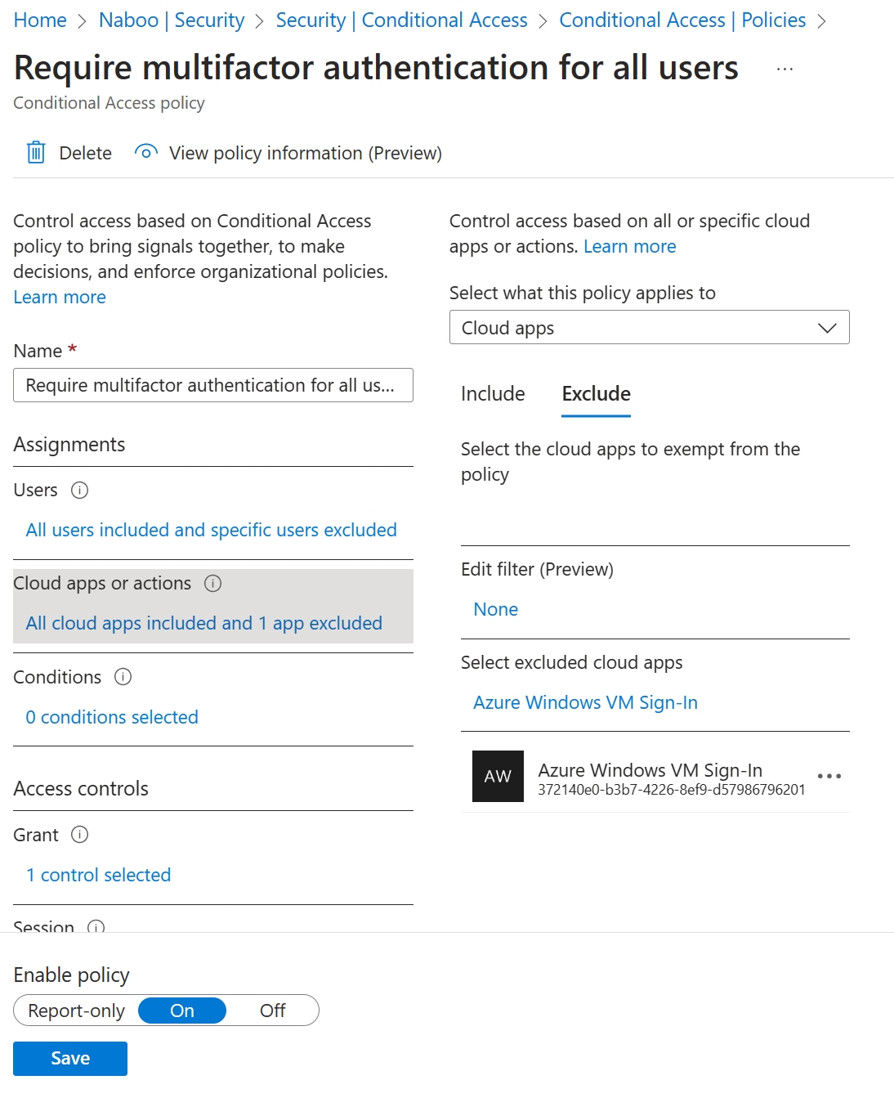

# Azure Virtual Desktop workspace

The Azure Virtual Desktop environment for the workspace is now available and can be used. This chapter will test the workspace functionality.

The user used to login cannot be a Guest user in the Azure Active Directory tenant and needs to have MFA setup to be able to access the workspace.

Make sure you performed section 7.1, Remote Desktop client before attempting to start this chapter.

## Connect to the Azure Virtual Desktop environment with the Remote Desktop application

1. In the search bar in your Windows task bar, type “Remote Desktop”.
2. Open the application.
3. Click the ellipses (…) in the right upper hand corner and select **Subscribe.** If you want to use the **Subscribe with URL**, use the following URL [[Remote Desktop Web Client (microsoft.com)](https://client.wvd.microsoft.com/arm/webclient/index.html)](https://rdweb.wvd.microsoft.com).
4. Fill in the email address of the user AdeleV and sign in.
5. As AdeleV is member of only the SG-AVD workspace users group, he will only see the Workspace being available. Open the desktop and see a desktop available for this user while logging in with Azure Active Directory credentials.
6. Click the ellipses (…) in the right upper hand corner and select **Subscribe.** If you want to use the **Subscribe with URL**, use the following URL [Remote Desktop Web Client (microsoft.com)](https://client.wvd.microsoft.com/arm/webclient/index.html).
7. Fill in the email address of the user NestorW and sign in.
8. As NestorW is member of only the SG-AVD applications users group, he will only see the Applications (at least Word) being available. Open the Word application and see the app available for this user while logging in with Azure Active Directory credentials.
9. Click the ellipses (…) in the right upper hand corner and select **Subscribe.** If you want to use the **Subscribe with URL**, use the following URL [Remote Desktop Web Client (microsoft.com)](https://client.wvd.microsoft.com/arm/webclient/index.html).
10. Fill in the email address of the user MeganB and sign in.
11. As MeganB is member of both SG-AVD users group, she will see as well the the Applications (at least Word) as the Desktop being available. Open the Word application and see the app available for this user while logging in with Azure Active Directory credentials.. Open the desktop and see a desktop available for this user while logging in with Azure Active Directory credentials.

## Connect to the Azure Virtual Desktop environment with the browser

1. Open an InPrivate browser session in Microsoft Edge.
2. Open the following URL [Remote Desktop Web Client (microsoft.com)](https://client.wvd.microsoft.com/arm/webclient/index.html)
3. Login with the email address of the user AdeleV and sign in.
4. As AdeleV is member of only the SG-AVD workspace users group, she will only see the Workspace being available. Open the desktop and see a desktop available for this user while logging in with Azure Active Directory credentials.
5. Close the browser and open a new InPrivate browser session in Microsoft Edge.
6. Login with the email address of the user MarianG and sign in.
7. As NestorW is member of only the SG-AVD application users group, he will only see the Applications (at least Word) being available. Open the Word application and see the app available for this user while logging in with Azure Active Directory credentials.
8. Close the browser and open a new InPrivate browser session in Microsoft Edge.
9. Login with the email address of the user MeganB and sign in.
10. As MeganB is member of both SG-AVD users group, she will see as well the the Applications (at least Word) as the Desktop being available. Open the Word application and see the app available for this user while logging in with Azure Active Directory credentials.. Open the desktop and see a desktop available for this user while logging in with Azure Active Directory credentials.

# Best Practice 1: Scale the host pool for demand

To only pay for the resources needed, make sure you scale your host pool.

[Create an autoscale scaling plan for Azure Virtual Desktop | Microsoft Learn](https://learn.microsoft.com/en-us/azure/virtual-desktop/autoscale-scaling-plan)

# Best Practice 2: Hybrid Scenarios

# Appendix 1 – Language settings

## Language settings in the Azure portal

In the Azure (Active Directory) portal in the upper right hand corner, click on the clog icon. Go to Language and region settings. Select here your preferred language and the regional settings.

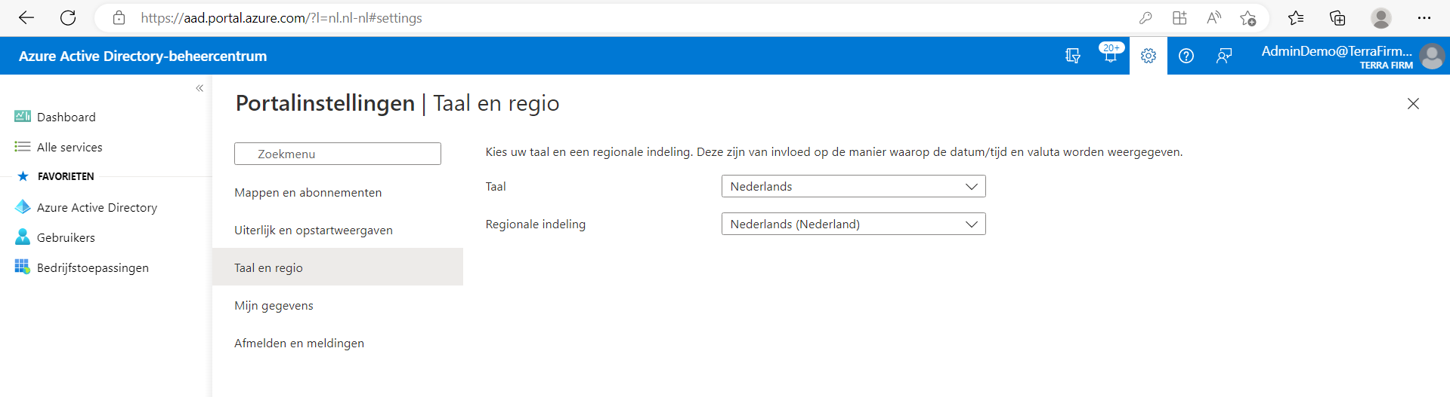

# Appendix 2 – Resources

[Azure Virtual Desktop documentation | Microsoft Learn](https://learn.microsoft.com/en-us/azure/virtual-desktop/)

## Add Microsoft Business Premium Licenses – credit card required

Important note: Only when instructed to do so

Time to add the Microsoft 365 Business Premium-licenses to the tenant. These licenses are trial licenses and can be used for a one-month period.

To do so, a user within the tenant is needed to request the licenses.

## Go to the Azure Portal (<https://portal.azure.com> ) using the Edge browser profile attached to your administrator account as created in paragraph 7.1 Remote Desktop client

To be able to connect to the Azure Virtual Desktop as a user, the Remote Desktop client needs to be installed on your computer.

Check if the application has been installed on your computer:

1. In the search bar in your Windows task bar, type “Remote Desktop”
2. If installed the application will be available in the search results
3. Open the application
4. Click the ellipses (…) in the right upper hand corner and select **About**
5. Check the version number of your application, this should be 1.2.4240.0 or higher. There should as well be a green checkmark with the text “You’re up to date ”.
6. If you are up to date, no further action is necessary, if not please follow the next steps to install the correct Remote Desktop application

Install the Remote Desktop application:

1. Use the following link to download the Windows 64-bit version of the application.
2. Click on the downloaded file to install the application
3. After the install, follow the steps in the previous paragraph, to ensure the application installed successfully.

## Create a new Azure tenant

To be able to perform this lab an Azure tenant is needed. As you do not want to play around in your companies or customers Azure tenant, we will use a new tenant.

In this section you will find the steps to request such a tenant.

Note: Please use a new Microsoft account for this tenant to make sure the tenant is not linked to any existing environments.

Open the Edge browser using an InPrivate window.

1. **Open** the following page to request a new trial https://signup.live.com.
2. A sign in window appears. In this window click the “No account? **Create one**” link available
3. Click the **Get a new email address link**.
4. Create a new account name e.g. avdrocks@outlook.com. Store the account name for later reference. Click the **Next** button.
5. Enter a new password for this account. Store the password for later reference. Click the **Next** button.
6. The message that a little more information is needed appears. Fill in a first and last name. Click the **Next** button.
7. Select your country and Birthdate. Click the **Next** button.
8. The message to solve a puzzle to prove you are not a robot appears. Click the **Next** button.
9. Solve the puzzle(s) and click **Submit**.
10. The **Confirmation Verification** complete appears on the screen and you are redirected to a new window page.
11. On this new page **fill in your information**. Make sure that as an email address you fill in the email address created in step 5.
12. Use one of the **verification methods** (Text or Call) to verify your phone number.
13. Select at least the “I agree to the customer agreement” box before clicking the **Next** button.
14. Your account has been created.
15. In the same browser window, open the azure portal https://portal.azure.com.
16. Login with your new user account (if needed).
17. A new tenant called mynewuseraccount.onmicrosoft.com e.g. avdrocksoutlook.onmicrosoft.com will be created. This can take a while to be fully available.

## Add the Lab environment subscription to your tenant

The email you received from your partner for this training contains a link to redeem your lab environment subscription.

1. Open the link from the email in an InPrivate Edge browser window.
2. Click on the **blue Labs button** to launch the lab.
3. Follow the steps in **Module 0** to redeem a subscription and add it to your previously created Azure Active Directory. Use the **account** that you have **just created**.
4. Instead of moving ahead with “Required Lab Setup” step, close the lab.

## Create a new user to become Global Admin

Your just created live account cannot perform all actions, so we need an account which is part of the Azure Active Directory tenant. In this section you will create a new user and assign the Global Administrator role to the user.

Login to the Azure Portal with the newly created outlook.com account in Edge using an InPrivate window.

1. In the **search bar** at the top of the Azure Portal, type “aad”.
2. In the **search results**, click “**Azure Active Directory**” under “Services”, the Azure Active Directory page will open
3. On the Azure Active Directory page, in the left hand navigation , under manage, click “**Users**”.
4. Click **New user**.
   1. Username: e.g. adminadv
   2. Name: e.g. Admin AVD
   3. Configure password: or use the generated one
   4. Assign the Global Administrator role
5. Click **Create**.

## Add the Admin account to the Edge Browser

To work in Microsoft Edge with another account it is recommended to work with an Microsoft Edge-profile linked to the account in this hands-on lab.

Usage of profile will allow for quick switching between this demo-environment and your production environment

1. Open a new instance of Microsoft Edge.
2. Click on the circle with your profile picture or initials in the top bar. (Depending on your browser version, it can be found in the top left or top right corner)
3. Click the settings icon in the top right corner
4. Click **Add a Browser**.
5. Click **Add** .
6. Click **Choose an account** and select **+ Add new account**
7. Click **Sign in to sync data**
8. Fill in the sign in information. (*Hint: username is avdadmin@xxxx.onmicrosoft.com*) click **Next**.
9. Fill in the password and click **Sign in** .
10. The “More information is required” message will appear to setup MFA for this user. Click **Next**.
11. On the next page follow the steps to get the Authenticator app if not already installed on your device. Click **Next** when the Authenticator is installed.
12. In the Authenticator app click **Add an account** and select **Work or School**. In the browser wizard click **Next**.
13. In the Authenticator app click **Scan the QR code** and scan the QR code in the wizard in the browser and click Next
14. A number will appear in the wizard that should be filled in in the Authenticator and click **Yes**
15. After that approve with your personal Authenticator pin code, a “Notification approved” message will appear in the wizard in the browser.
16. Click **Next** in the browser wizard
17. A success message will appear, click **Done**.
18. If the question arises or you would like to stay signed in, click “**No**”.
19. Click **Next**.
20. Click **Finish**.

## Grant access on the subscription to the Global Admin

From a security perspective a new Global Administrator does not have access to any subscriptions or Management groups. Now you sign in as the newly created Global Administrator and grant yourself permissions to the Azure Pass Subscription.

Go to the Azure Portal (https://portal.azure.com ) using the Edge browser profile attached to your administrator account as created in paragraph “7.5 Add the Admin account to the Edge Browser”.

1. In the **search bar** at the top of the Azure Portal, type “aad”.
2. In the **search results**, click “**Azure Active Directory**” under “Services”, the Azure Active Directory page will open
3. On the Azure Active Directory page, in the left hand navigation , under manage, click “**Properties**”.
4. Adjust the toggle for “Access management for Azure resources” to **Yes**.

Note: This toggle is very powerful and will grant you all permissions on the tenant. In real-life do use only with a 4-eyes principle.

1. Click **Save** at the top of the page to confirm the adjusted setting.
2. As you browser cookies still might reference to your old permissions. Close the browser session. Start a new Edge browser using the Edge browser profile and logon with the same account to the azure portal.
3. In the **search bar** at the top of the Azure Portal, type “subscriptions”.
4. In the **search results**, click “**Subscriptions**” under “Services”, the Subscriptions page will open.
5. The **Azure Pass subscription** should be visible now.
6. Click on the Azure Pass subscription, the Azure Pass Subscription page will open.
7. On the Azure Pass Subscription page, in the left hand navigation , click “**Access Control (IAM)**”, the IAM page will open.
8. On the IAM page, click the **Add role assignment** button, to grant yourself owner permissions to this subscription.
9. In the Role Assignment wizard, on the Role tab, click **Privileged administrator roles**.
10. Select the **Owner** role and click **Next**.
11. On the Members tab, click the **+ Select members** link.
12. On the right hand side, search for your current account and click the **Select button**.
13. Click the **Review + Assign** **button**.
14. Click again the **Review + Assign** **button** .to grant the permissions.
15. As there is no need to have access to all resources anymore. You will turn off this feature. In the **search bar** at the top of the Azure Portal, type “aad”.
16. In the **search results**, click “**Azure Active Directory**” under “Services”, the Azure Active Directory page will open
17. On the Azure Active Directory page, in the left hand navigation , under manage, click “**Properties**”.
18. Adjust the toggle for “Access management for Azure resources” back to **No**.
19. Click **Save** at the top of the page to confirm the adjusted setting.
20. As you browser cookies still might reference to your old permissions. Close the browser session.

## Add Microsoft Business Premium Licenses

Time to add the Microsoft 365 Business Premium-licenses to the tenant. These licenses are trial licenses and can be used for a one-month period.

Go to the Azure Admin Portal (https://admin.microsoft.com) using the Edge browser profile attached to your administrator account as created in paragraph “7.5 Add the Admin account to the Edge Browser”.

1. Click **Billing** in the Microsoft 365 admin center.
2. Under Billing click **Purchase Services**.
3. Search for **Microsoft 365 Business Premium**.

**Note**: There are different offerings Microsoft 365. Please select the **Microsoft 365 Business Premium**. Make sure not to select the (month to month) offering.

1. Click **Details**
2. On the Microsoft 365 Business Premium page click **Start free trial version**.
3. Prove you are not a robot by providing your cell phone number. Click **Sms me**.
4. Provide your verification code and click **Start your free trial period**.
5. Click **Try now**.
6. Click **Continue**.

You return to the homepage of the Microsoft 365 admin center.

1. Expand **Billing** and click **Licenses**.

Check or the Microsoft 365 Business Premium licenses are available to you

Note: In case the following message will appear, click **Continue**and take a close look the steps in this section.

1. In the **search bar** at the top of the Azure Portal, type “aad”.
2. In the **search results**, click “**Azure Active Directory**” under “Services”, the Azure Active Directory page will open
3. On the Azure Active Directory page, in the left hand navigation , under manage, click “**Users**”.
4. Click **New user**.
   1. Username: adminadv
   2. Name: Admin AVD
   3. Configure password: or use the generated one
   4. Assign the Global Administrator role
5. Click **Create**.
6. Use an InPrivate Edge browser session using an InPrivate window.
7. Go to the [Microsoft 365 Business Premium | Microsoft 365](https://www.microsoft.com/en-us/microsoft-365/business/microsoft-365-business-premium?activetab=pivot%3aoverviewtab) web page.
8. Click the **Try free for one month** button.
9. Select the amount of users you want the trial licenses for (max. 25). For this lab a minimal amount of 3 licenses are necessary.
10. Click **next**.
11. Fill in the account you just created in the lab environment.
12. Click **next**.
13. On the let’s get started page “Looks like the account is assigned to a tenant already. Sign in or create a new account. Click **Sign account**.
14. Login with the newly created account. Update the password and redirect to your hands-on lab tenant.
15. Prove you are not a robot by providing your cell phone number. Click **Sms me**.
16. Provide your verification code and click **Start your free trial period**.
17. Click **Try now**.
18. Click **Continue**.
19. Fill in your information. Click **Next**.
20. On the “Tell us about you” page, fill in the details to receive a verification code.
21. Fill in the code and click **Verify Code**.
22. Fill in a domain name and set a password. Click **Next**.
23. Click **Add payment method**.
24. Provide payment details and click **Save**.

## Sign-up for an Azure trial (credit card needed)

To be able to perform this lab an Azure tenant is needed. As you do not want to play around in your companies or customers Azure tenant, we will use a new trial tenant.

In this section you will find the steps to request such a trial tenant.

Note: Please use a new Microsoft account for this trial tenant to make sure the tenant is not linked to any existing environments.

Open the Edge browser using an InPrivate window.

1. **Open** the following page to request a new trial [Create Your Azure Free Account Today | Microsoft Azure](https://azure.microsoft.com/en-us/free/).
2. Click the **Start free** button on the page.
3. A sign in window appears. In this window click the “No account? **Create one**” link available
4. Click the **Get a new email address link**.
5. Create a new account name e.g. [avdrocks@outlook.com](mailto:avdrocks@outlook.com). Store the account name for later reference. Click the **Next** button.
6. Enter a new password for this account. Store the password for later reference. Click the **Next** button.
7. Select your country and Birthdate. Click the **Next** button.
8. The message to solve a puzzle to prove you are not a robot appears. Click the **Next** button.
9. Solve the puzzle(s) and click **Submit**.
10. The **Confirmation Verification** complete appears on the screen and you are redirected to a new window page.
11. On this new page **fill in your information**. Make sure that as an email address you fill in the email address created in step 5.
12. Use one of the **verification methods** (Text or Call) to verify your phone number.
13. Select at least the “I agree to the customer agreement” box before clicking the **Next** button.

In the **search results**, click “**Azure Active Directory**” under “Services”, the Azure Active Directory